**Project Planning Phase**

**Project Planning Template (Product Backlog, Sprint Planning, Stories, Story points)**

|  |  |
| --- | --- |
| Date | 22 October 2022 |
| Team ID | PNT2022TMID18010 |
| Project Name | Smart Lender - Applicant Credibility Prediction for Loan Approval |
| Maximum Marks | 8 Marks |

**Product Backlog, Sprint Schedule, and Estimation (4 Marks)**

Use the below template to create product backlog and sprint schedule

| **Sprint** | **Functional Requirement (Epic)** | **User Story Number** | **User Story / Task** | **Story Points** | **Priority** | **Team Members** |
| --- | --- | --- | --- | --- | --- | --- |
| Sprint-1 | **Pre – processing** | USN-1 | Need for the data to be clean enough for Model Prediction | 5 | High | Pranava Kailash S P |
| Sprint-1 | **Web UI** | USN-2 | As a user, I would need a place to enter my data to predict my results | 3 | High | Dharshana R |
| Sprint-2 | **Model Creation** | USN-3 | As the data is clean now, the data can be used to Train and Evaluate the results | 4 | Medium | Pranava Kailash S P |
| Sprint-3 | **Integration of Model and Web UI** | USN-4 | Using Flask, now we can integrate the Model with the input given by the user | 2 | Medium | Pranava Kailash S P, Dharshana R |
| Sprint-4 | **Deployment in the Cloud** | USN-5 | After Complete integration, now the model should be deployed in IBM Cloud and put for use | 1 | Medium | Pranava Kailash S P, Dharshana R |

**Project Tracker, Velocity & Burndown Chart: (4 Marks)**

| **Sprint** | **Total Story Points** | **Duration** | **Sprint Start Date** | **Sprint End Date (Planned)** | **Story Points Completed (as on Planned End Date)** | **Sprint Release Date (Actual)** |
| --- | --- | --- | --- | --- | --- | --- |
| Sprint-1 | 8 | 6 Days | 24 Oct 2022 | 29 Oct 2022 | 8 | 29 Oct 2022 |
| Sprint-2 | 4 | 6 Days | 31 Oct 2022 | 05 Nov 2022 | 4 | 05 Nov 2022 |
| Sprint-3 | 2 | 6 Days | 07 Nov 2022 | 12 Nov 2022 | 2 | 12 Nov 2022 |
| Sprint-4 | 1 | 6 Days | 14 Nov 2022 | 19 Nov 2022 | 1 | 19 Nov 2022 |

**Velocity:**

Imagine we have a 10-day sprint duration, and the velocity of the team is 20 (points per sprint). Let’s calculate the team’s average velocity (AV) per iteration unit (story points per day)

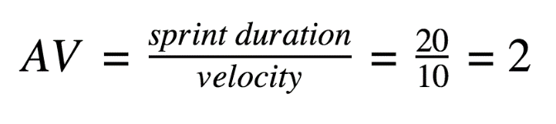

**AV = Sprint duration / Velocity = 15/6 = 2.5**

**Burndown Chart:**

A burn down chart is a graphical representation of work left to do versus time. It is often used in agile[software development](https://www.visual-paradigm.com/scrum/what-is-agile-software-development/) methodologies such as [Scrum](https://www.visual-paradigm.com/scrum/scrum-in-3-minutes/). However, burn down charts can be applied to any project containing measurable progress over time.

SPRINT-1

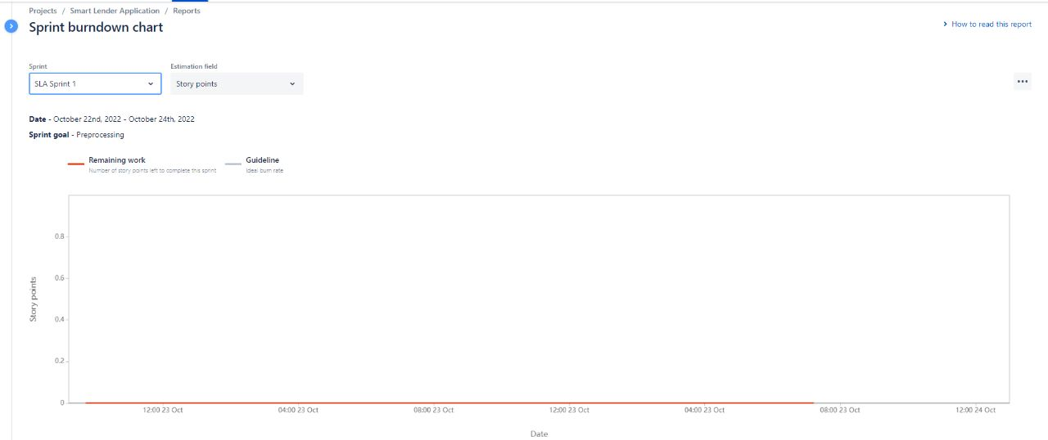

SPRINT-2

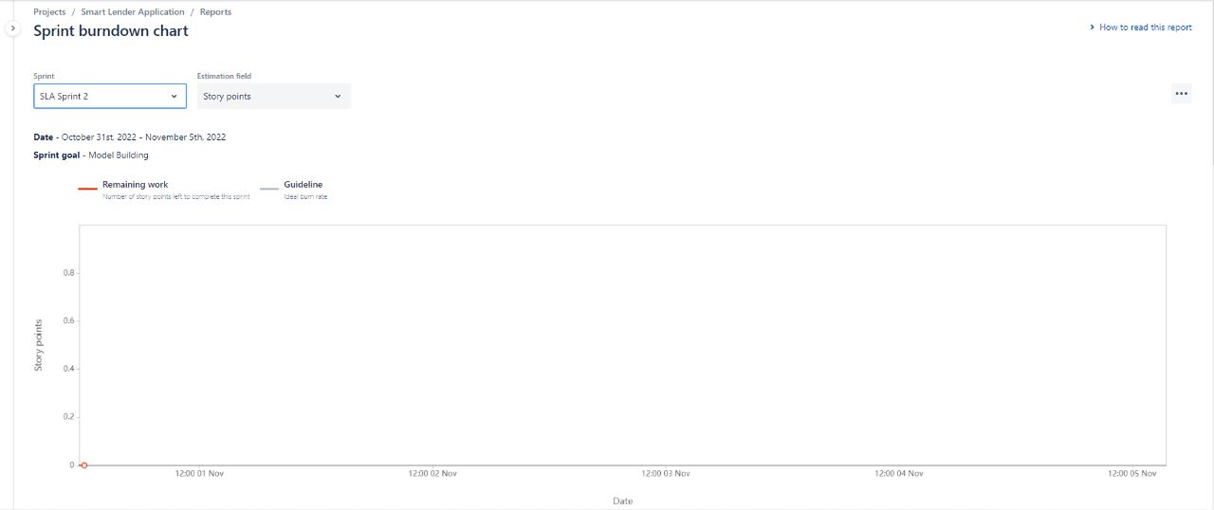

SPRINT-3

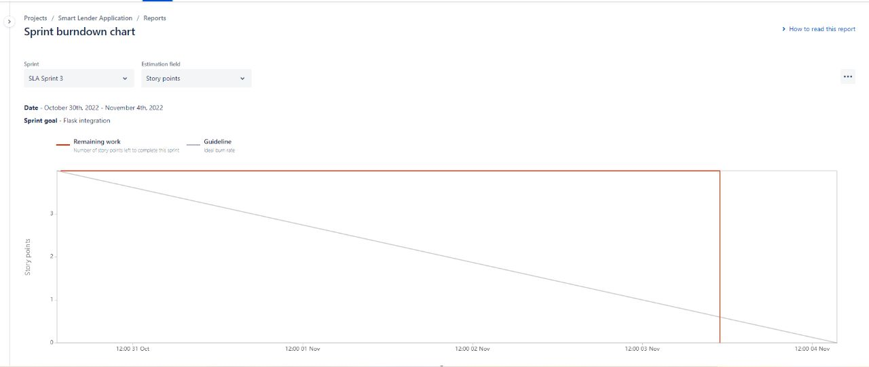

SPRINT-4

